SIMATS ENGINEERING

ASSESSMENT TOOL 1

COURSE NAME: Database Management Systems COURSE CODE: CSA05

COURSE OUTCOME COVERED

CO1: Analyze DBMS architecture, different data models, schema types, and design ER/EER diagrams, relational schemas for case-based scenarios by identifying entities and relationships. (BL1, BL2)

Activity Tool : Short Answer Text(High) Assessment Tool Weightage: 30%

Dr

QUESTIONS Total Marks: 50
Q.N  o | Question | Bloom's Level | Marks
1 | UPS Product Tracking Information System  UPS prides itself on having up-to-date information on the processing and current location of each shipped item. To do this, UPS relies on a company-wide information system. Shipped items are the heart of the UPS product tracking information system. Shipped items can be characterized by item number (unique), weight, dimensions, insurance amount, destination, and final delivery date. Shipped items are received into the UPS system at a single retail center. Retail centers are characterized by their type, uniqueID, and address. Shipped items make their way to their destination via one or more standard UPS transportation events (i.e., flights, truck deliveries). These transportation events are | BL1 –  Remember | 5

 | characterized by a unique schedule Number, a type (e.g, flight, truck), and a delivery Route. Create an Entity Relationship diagram that captures this information about the UPS system.
2 | Course Management System  Consider a university database for the scheduling of classrooms for final exams. This database could be modeled as the single entity set exam, with attributes course-name, section-number, room-number, and time. Alternatively, one or more additional entity sets could be defined, along with relationship sets to replace some of the attributes of the exam entity set, as  - course with attributes name, department, and c-number  - section with attributes s-number and enrollment, and dependent as a weak entity set on course  - room with attributes r-number, capacity, and building Show an E-R diagram illustrating the use of all three additional entity sets listed. | BL2 –  Understand | 5
3 | University Registrar’s Office Management System  A university registrar’s office maintains data about the following entities:  - courses, including number, title, credits, syllabus, and prerequisites;  - course offerings, including course number, year, semester, section number, instructor(s), timings, and classroom;  - students, including student-id, name, and program;  - instructors, including identification number, name, department, and title.  - Further, the enrollment of students in courses and grades awarded to students in each course they are enrolled for must be appropriately modeled.  Construct an E-R diagram for the registrar’s  office. | BL2 –  Understand | 5

4 | Hospital Management System  Construct an E-R diagram for a hospital with a set of patients and a set of medical doctors.  Associate with each patient a log of the various tests and examinations conducted. Construct appropriate tables for the above ER Diagram :  Patient (SS#, name, insurance) Physician ( name, specialization) Test-log( SS#, test-name, date, time)  Doctor-patient (physician-name, SS#) Patient-history(SS#, test-name, date) | BL2 –  Understand | 5
5 | Company Project Management System  Construct an ER Diagram for Company having following details :  Company organized into DEPARTMENT. Each department has unique name and a particular employee who manages the department. Start date for the manager is recorded. Department may have several locations.  • A department controls a number of PROJECT. Projects have a unique name, number and a single location.  • Company’s EMPLOYEE name, ssno, address, salary, sex and birth date are recorded. An employee is assigned to one department, but may work for several projects (not necessarily controlled by dept). Number of hours/week an employee works on each project is recorded; The immediate supervisor for the employee.  • Employee’s DEPENDENT are tracked for health insurance purposes (dependent name, birthdate, relationship to employee). | BL2 –  Understand | 5
6 | Explain schema and instance with examples. Distinguish between logical schema, physical schema, and view schema. | BL1 –  Remember | 5
7 | Identify the entities, attributes, and relationships for a Bank Management System and construct its ER diagram. | BL2 –  Understand | 5

8 | Explain the Extended ER (EER) model. Describe the concepts of generalization, specialization, and aggregation. | BL2 –  Understand | 5
9 | Design an EER diagram for a Hospital Management System incorporating inheritance and weak entities. | BL2 –  Understand | 5
10 | Explain the role of a DBA (Database Administrator) and the responsibilities associated with the position. | BL1 –  Remember | 5

Code of Conduct:

I K Lokesh Chandra (192425358) (Name / Reg No) certify that this submission is my original work and that I have adhered to the guidelines specified for this assessment. I understand that any violation of academic integrity rules will result in disciplinary action.

K.Lokesh chandra
Signature of the student:

RUBRICS FOR CALCULATION:

Criteria | Weightage | Level 4 (Exemplary) | Level 3 (Proficient) | Level 2 (Developing) | Level 1 (Beginning)
Concept Identification | 30% | Demonstrates clear and complete understanding of the concept | Good understanding with minor gaps | Basic understanding with some misconceptions | Poor or incorrect  understandin g
Linkages | 25% | Completely correct answer with no errors | Mostly correct with minor errors | Partially correct with noticeable errors | Incorrect or irrelevant answer
Organization | 20% | Correctly applies concepts to solve the question/problem | Applies concepts with minor mistakes | Limited or partially correct application | No or incorrect application

Integration of Literature | 15% | Covers all required parts of the question | Covers most parts with minor omissions | Covers only some parts | Incomplete or missing response
Clarity | 10% | Clear, concise, and well-organized answer | Understandabl e with minor issues | Somewhat unclear or poorly structured | Difficult to understand
1. UPS Product Tracking Information System (ER Diagram)

Entities
Shipped_Item
- Item_No (PK)
- Weight
- Dimensions
- Insurance_Amount
- Destination
- Final_Delivery_Date
Retail_Center
- Center_ID (PK)
- Type
- Address
Transportation_Event
- Schedule_No (PK)
- Type (Flight/Truck)
- Delivery_Route
Relationships
- Retail_Center Receives Shipped_Item (1:M)
- Shipped_Item Transported_By Transportation_Event (M:N)

Simple ER Diagram

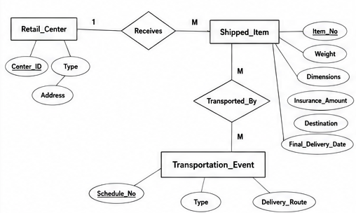

2. Course Management System (ER Diagram)

Entities
Course
- Name (PK)
- Department
- C_Number
Section (Weak Entity)
- S_Number (Partial Key)
- Enrollment
Room
- R_Number (PK)
- Capacity
- Building
Exam
- Time

Relationships
- Course Has Section (1:M)
- Section Scheduled_In Room
- Section Has Exam
ER Diagram
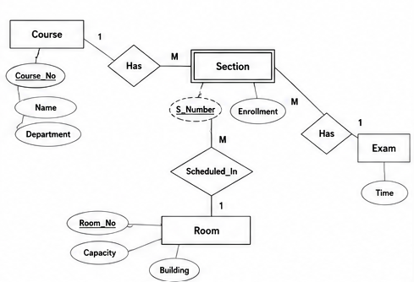

3. University Registrar's Office ER Diagram

Entities
Course
- Course_No (PK)
- Title
- Credits
- Syllabus
- Prerequisite
Course_Offering
- Year
- Semester
- Section
- Timing
- Classroom
Student
- Student_ID (PK)
- Name
- Program
Instructor
- Instructor_ID (PK)
- Name
- Department
- Title
Relationships
- Course → Course_Offering
- Instructor → Teaches → Course_Offering
- Student → Enrolls → Course_Offering
- Grade stored in Enrollment relationship.

ER Diagram
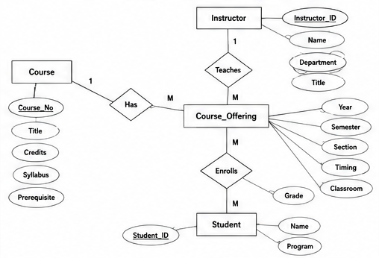
4. Hospital Management System

ER Diagram

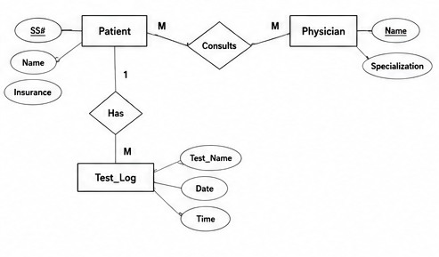
Tables
Patient
SS# | Name | Insurance
Physician
Name | Specialization
Test_Log
SS# | Test_Name | Date | Time
Doctor_Patient
Physician_Name | SS#
Patient_History
SS# | Test_Name | Date

5. Company Project Management System

Entities
Department
- Dept_No
- Dept_Name
Employee
- SSN
- Name
- Address
- Salary
- Sex
- Birth_Date

Project
- Project_No
- Project_Name
- Location
Dependent
- Dependent_Name
- Birth_Date
- Relationship
Relationships
- Department manages Project
- Department employs Employee
- Employee works on Project (Hours)
- Employee supervises Employee
- Employee has Dependents

ER Diagram

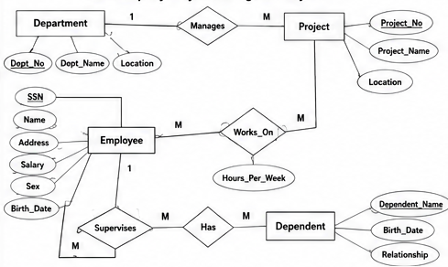

6. Schema and Instance

Schema
Schema is the structure or design of a database.
Example
Student (Student_ID, Name, Department)

Instance
Instance is the actual data stored in the database at a particular time.
Example
Student_ID | Name | Department
101 | Rahul | CSE
102 | Priya | AI

Difference
Logical Schema | Physical Schema | View Schema
Describes database structure | Describes storage on disk | Shows only required data
Used by developers | Used by DBA | Used by users
Independent of storage | Depends on storage | Customized view

7. Bank Management System

Entities
Customer
- Customer_ID
- Name
- Address
Account
- Account_No
- Type
- Balance
Branch
- Branch_ID
- Branch_Name
Loan
- Loan_No
- Amount

Relationships
- Customer owns Account
- Branch maintains Account
- Customer takes Loan

ER Diagram

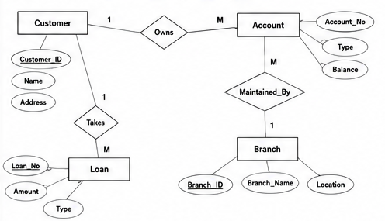

8. Extended ER (EER) Model

The Extended Entity Relationship (EER) Model is an advanced version of the ER model. It supports inheritance and specialization.
Generalization
Combines similar lower-level entities into one higher-level entity.
Example:
Savings Account
Current Account
↓
Account

Specialization
Divides one entity into smaller specialized entities.
Example:
Employee
|
---------
| |
Manager Engineer

Aggregation
Treats a relationship as a higher-level entity.
Example:
Employee ---- Works_On ---- Project

This relationship becomes one entity for another relationship.

9. Hospital Management System (EER Diagram)

Superclass
Person
- Person_ID
- Name
- Address

Subclasses
Patient
- Insurance
Doctor
- Specialization
Weak Entity
Medical_Record
- Record_No
- Date
- Treatment
Depends on Patient.
EER Diagram

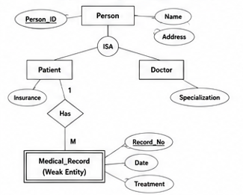

10. Role of DBA (Database Administrator)

A Database Administrator (DBA) manages and maintains the database.
Responsibilities
- Install database software.
- Create and maintain databases.
- Control user access.
- Perform backup and recovery.
- Ensure database security.
- Monitor performance.
- Optimize queries.
- Maintain data integrity.
- Update database software.
- Troubleshoot database issues.
Conclusion:
The DBA ensures the database is secure, available, reliable, and performs efficiently.

